**Part 1: Retrieving Data with SELECT**

**1.1 Retrieving All Expenses**

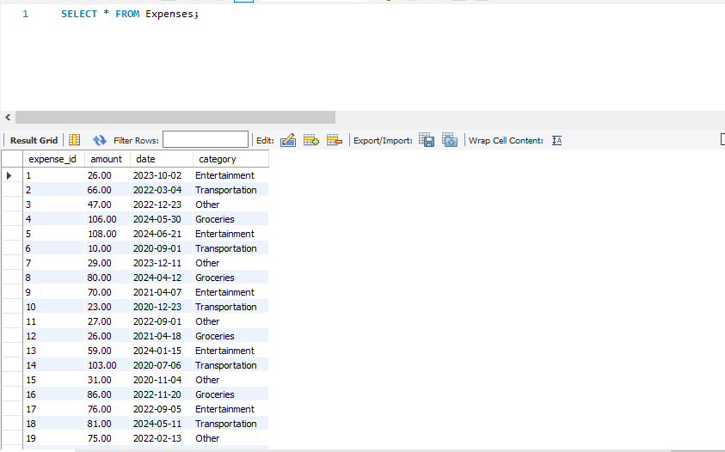



**1.2 Specific Columns**

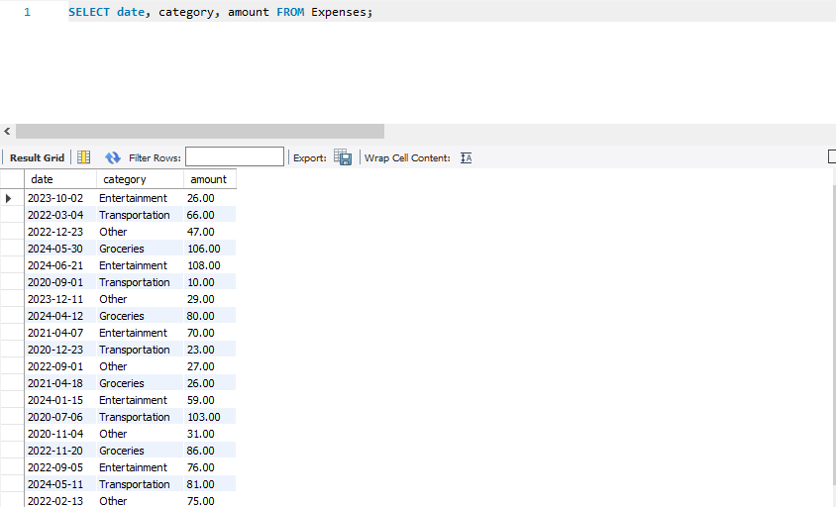 

**1.3 Filtering by Date Range**

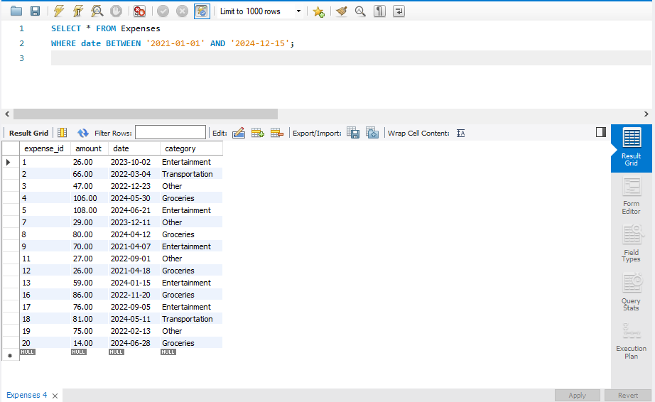

**Part 2: Filtering with WHERE Clause**

**2.1 Filtering by Category**

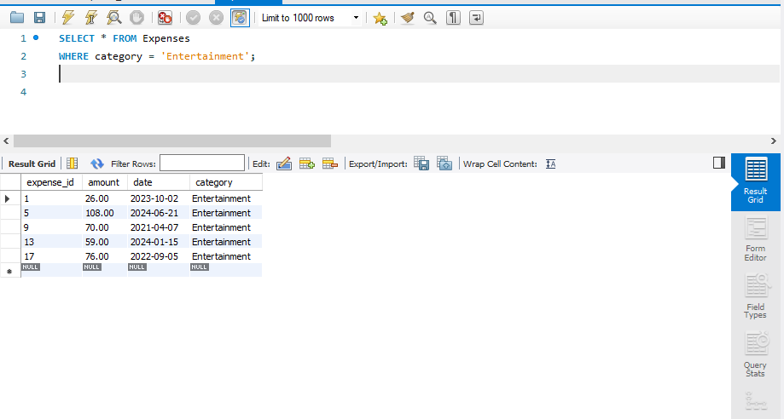

**2.2 Filtering with Comparison Operators**

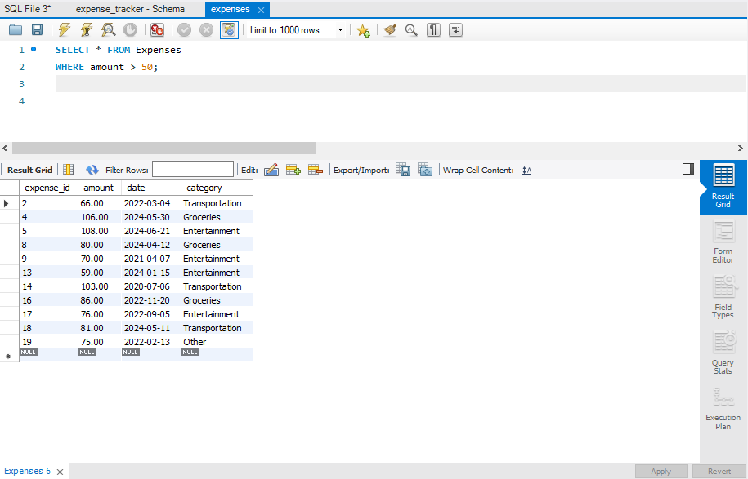

**2.3 Combining Filters (AND)**

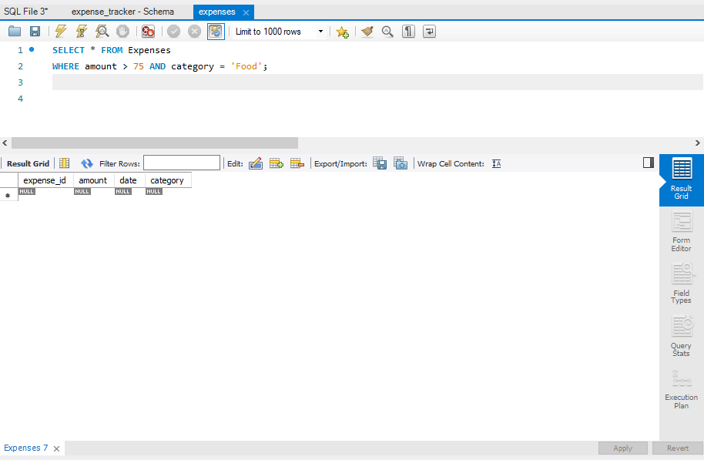

**2.4 Combining Filters (OR)**

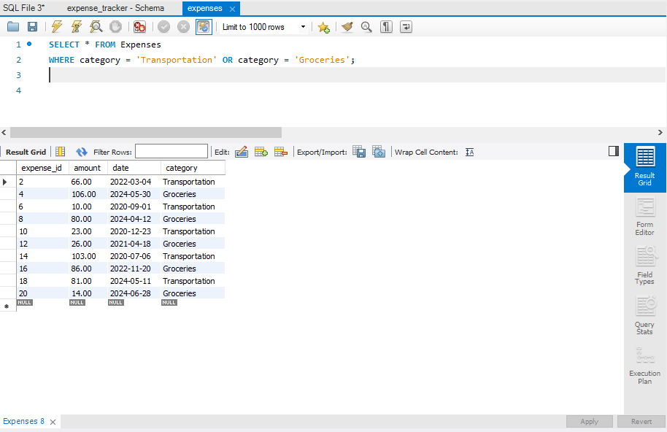

**2.3 Combining Filters (AND)**

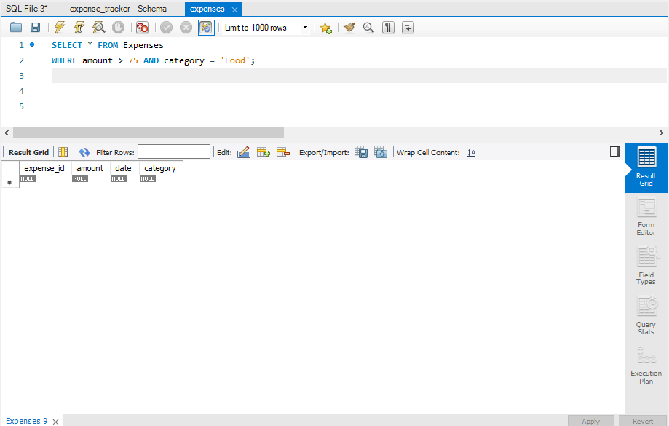

**2.4 Combining Filters (OR)**

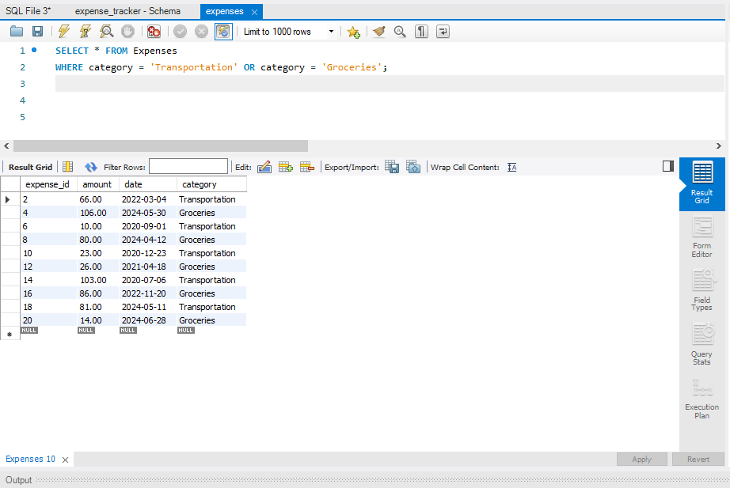

**2.5 Filtering with NOT**

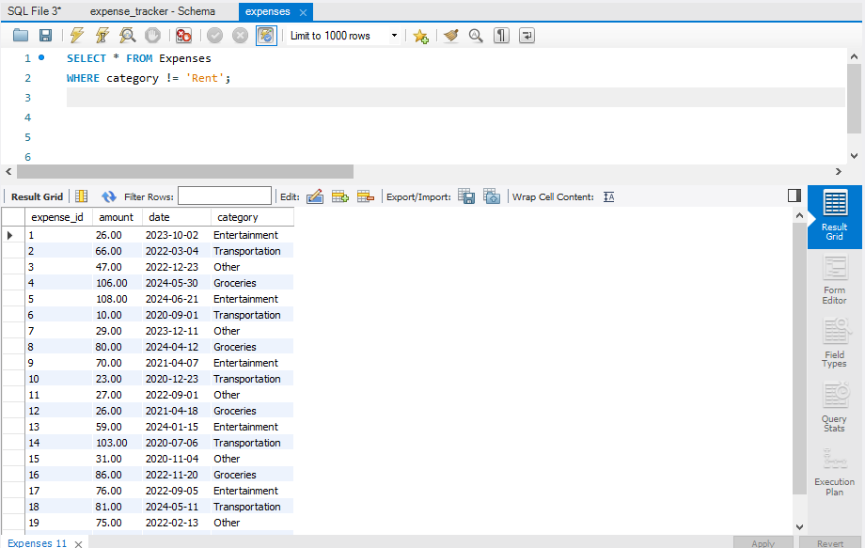 

**Part 3: Sorting Retrieved Data**

**3.1 Sorting by Amount**

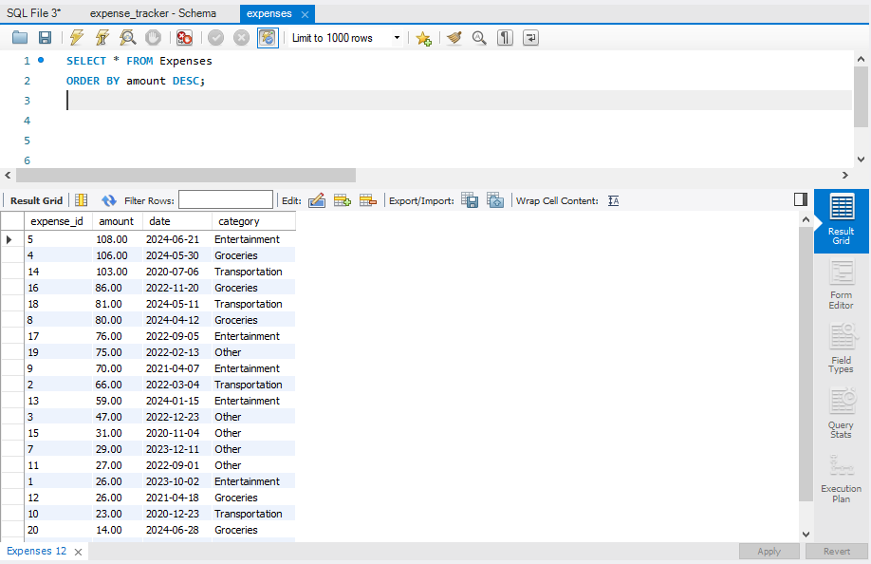 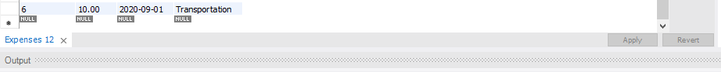

**3.2 Sorting by Date and Category**

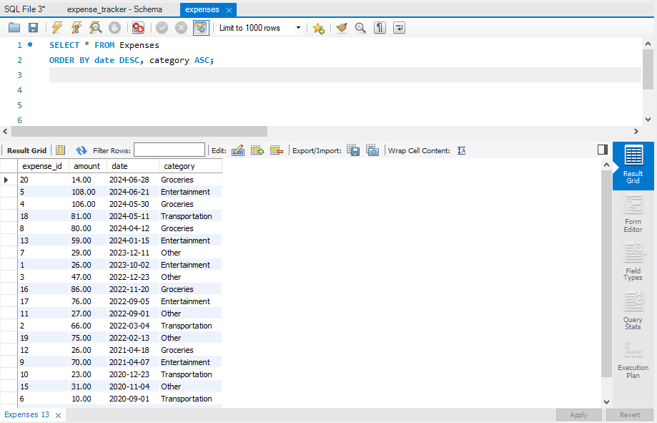 

**Part 4: Database Upgrade**

**4.1 Create the "Income" Table**

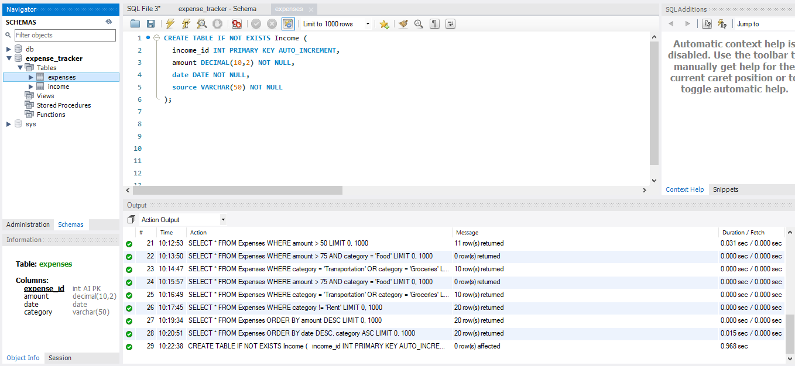

**4.2 Add a New Column "category" to "Income" Table**

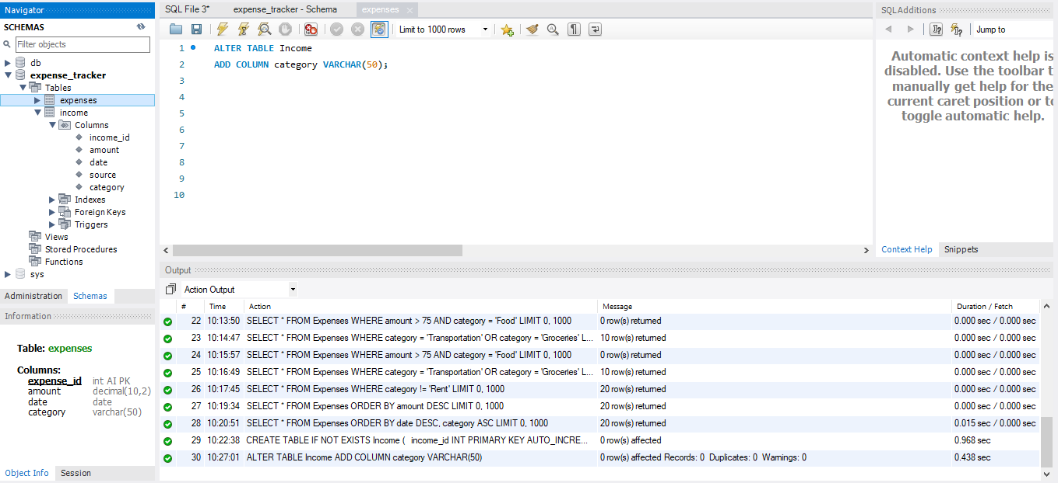

**4.3 Remove the "source" Column from "Income" Table**

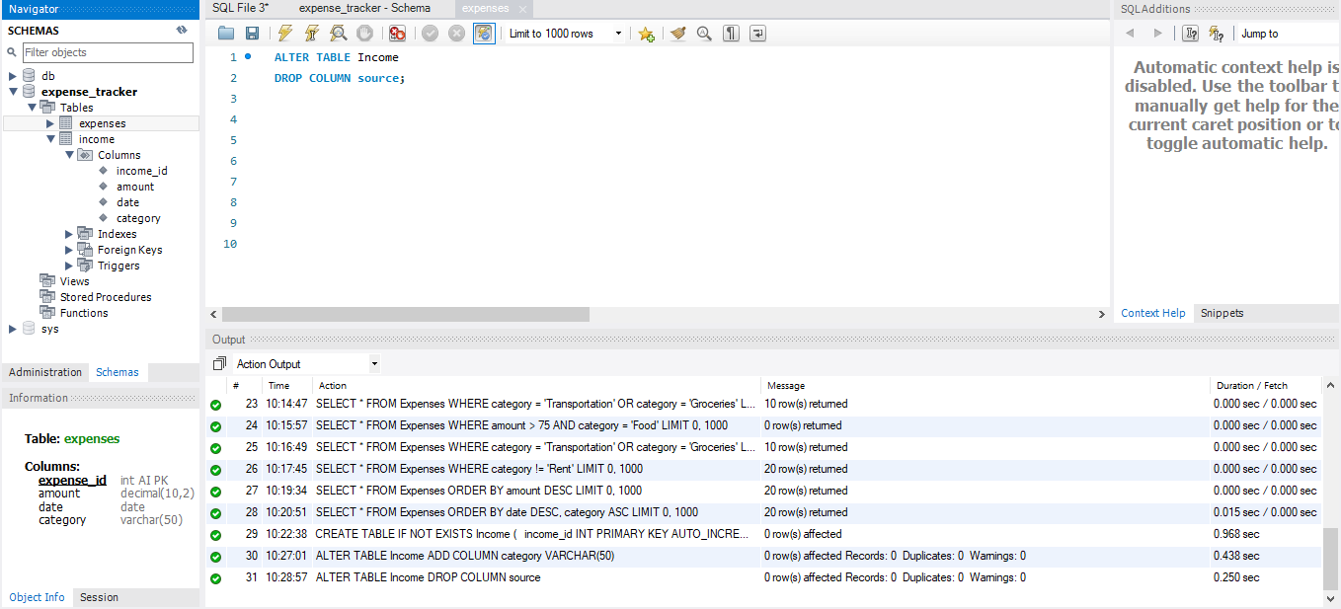

**4.4 Drop the "Income" Table**

